|  |
| --- |
| SENG 403: Software Development in teams and organizations |
| Iteration #3 Report |
| Group 4 |
|  |
| **James Bertram, Thomas Frampton, Ekaterina Grekova, Matthew Jones, Andrew Midwinter, Mark Mullen** |
| **4/9/2012** |

|  |
| --- |
|  |

Contents

Executive Summary 2

Project Summary 3

Progress during Iteration 3 3

Weekly Snapshots of the Storyboard during Iteration 3 3

System Evaluation 6

Work Distribution 6

Appendix A – All Stories 8

Appendix B – Backlog 9

# Executive Summary

The report presents the deliverables of Iteration 3 and system evaluation. The work progress during Iteration 3 is present in the Weekly Snapshot of the Storyboard section. After discussions among the group and with the customers, the plan for Iteration 3 was developed and executed. This report contains an overview of the project and the system. The tasks were managed in a fair manner, and appropriate feedback was provided to the group members.

# Project Summary

Table with the summary of each iteration

# Progress during Iteration 3

Retrospective for this iteration along with some pictures

Details on what needed to be changed in order to fulfill the new requirements.

Velocity

## Weekly Snapshots of the Storyboard during Iteration 3

During Iteration 3, different tasks were assigned to group members. We discussed those tasks and upon completion, we provided each other with the feedback for further improvements. The following snapshots of the storyboard illustrate how the project was progressing during Iteration 3. The snapshots were taken at the beginning of each week.

Figure 1. Storyboard snapshot at the beginning of week 1 in Iteration 3

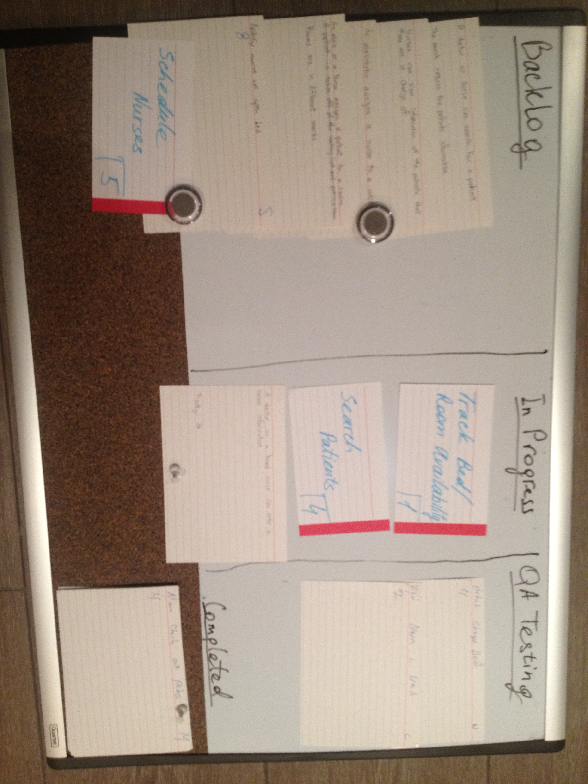

Figure . Storyboard snapshot at the beginning of week 2 in Iteration 3

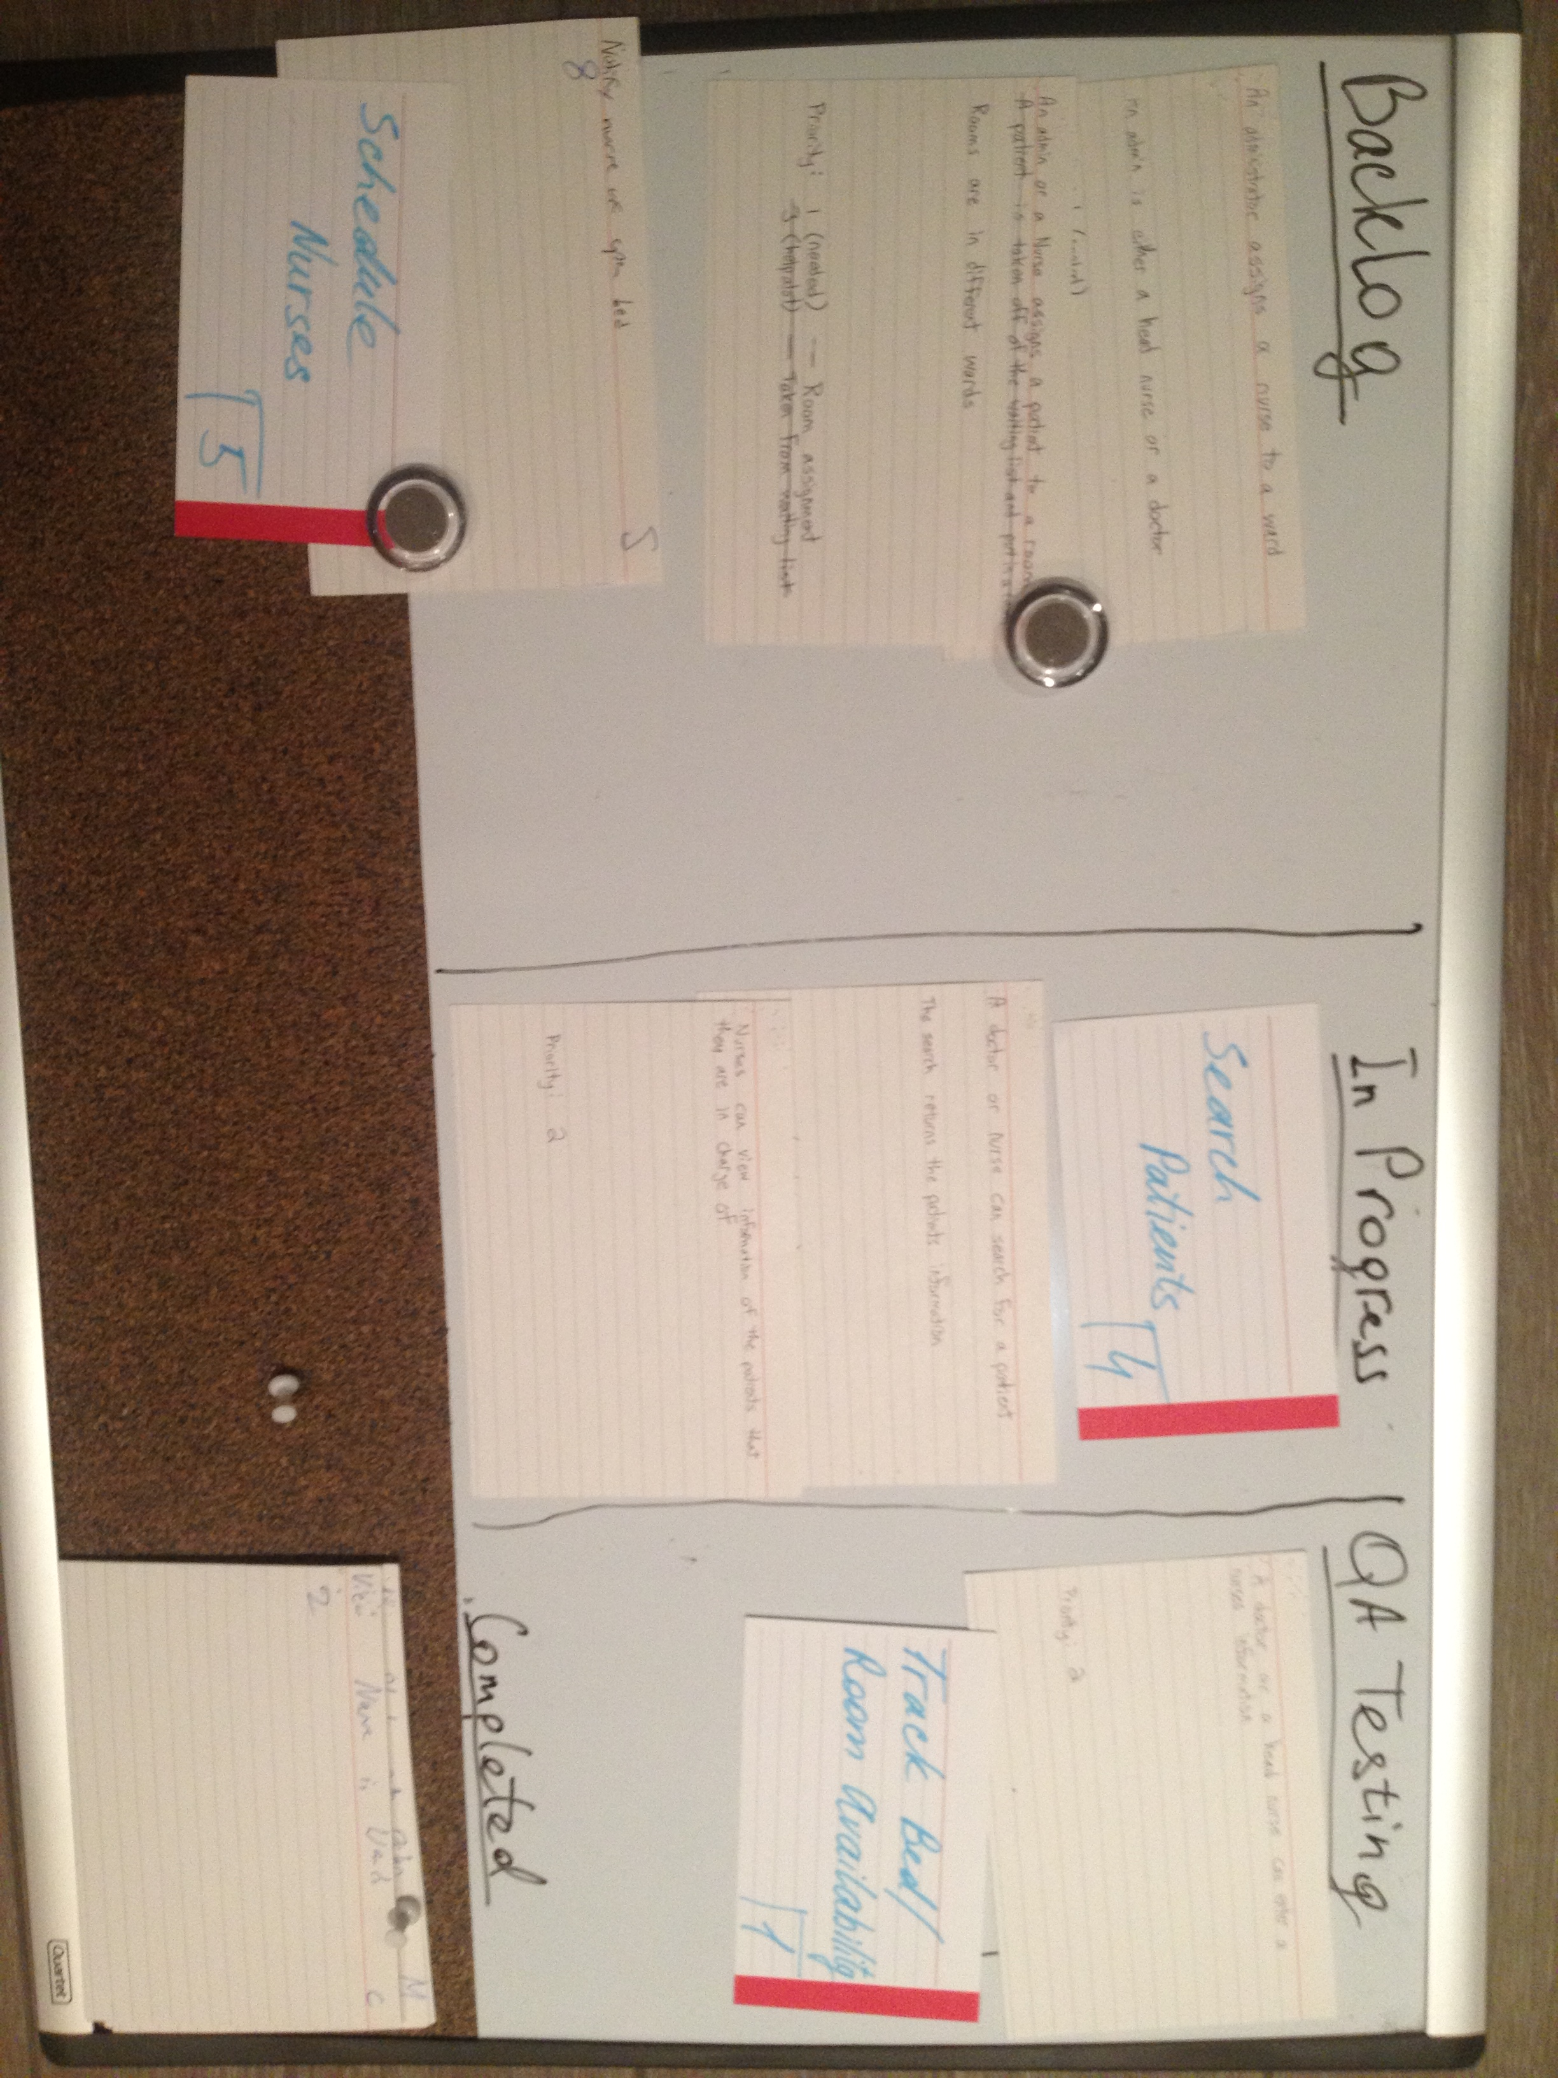

Figure 3. Storyboard snapshot at the beginning of week 3 in Iteration 3

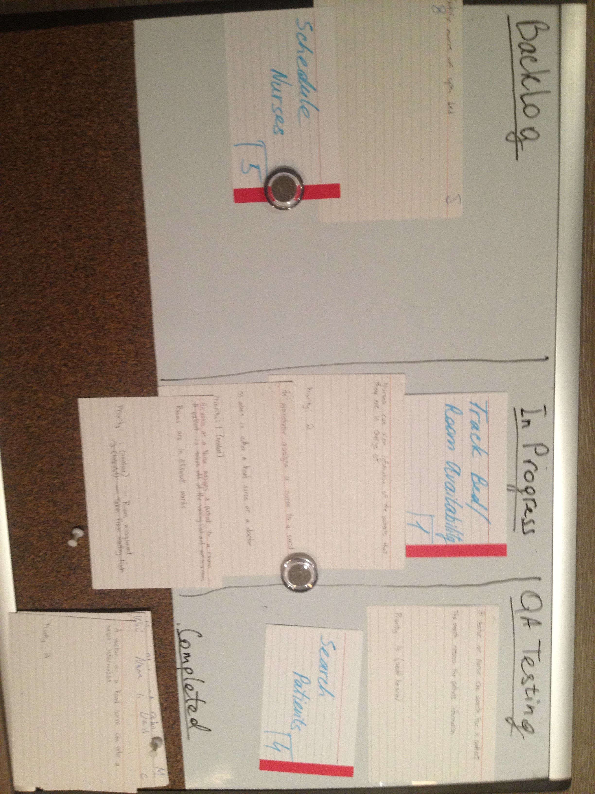

Figure . Storyboard snapshot at the beginning of week 4 in Iteration 3

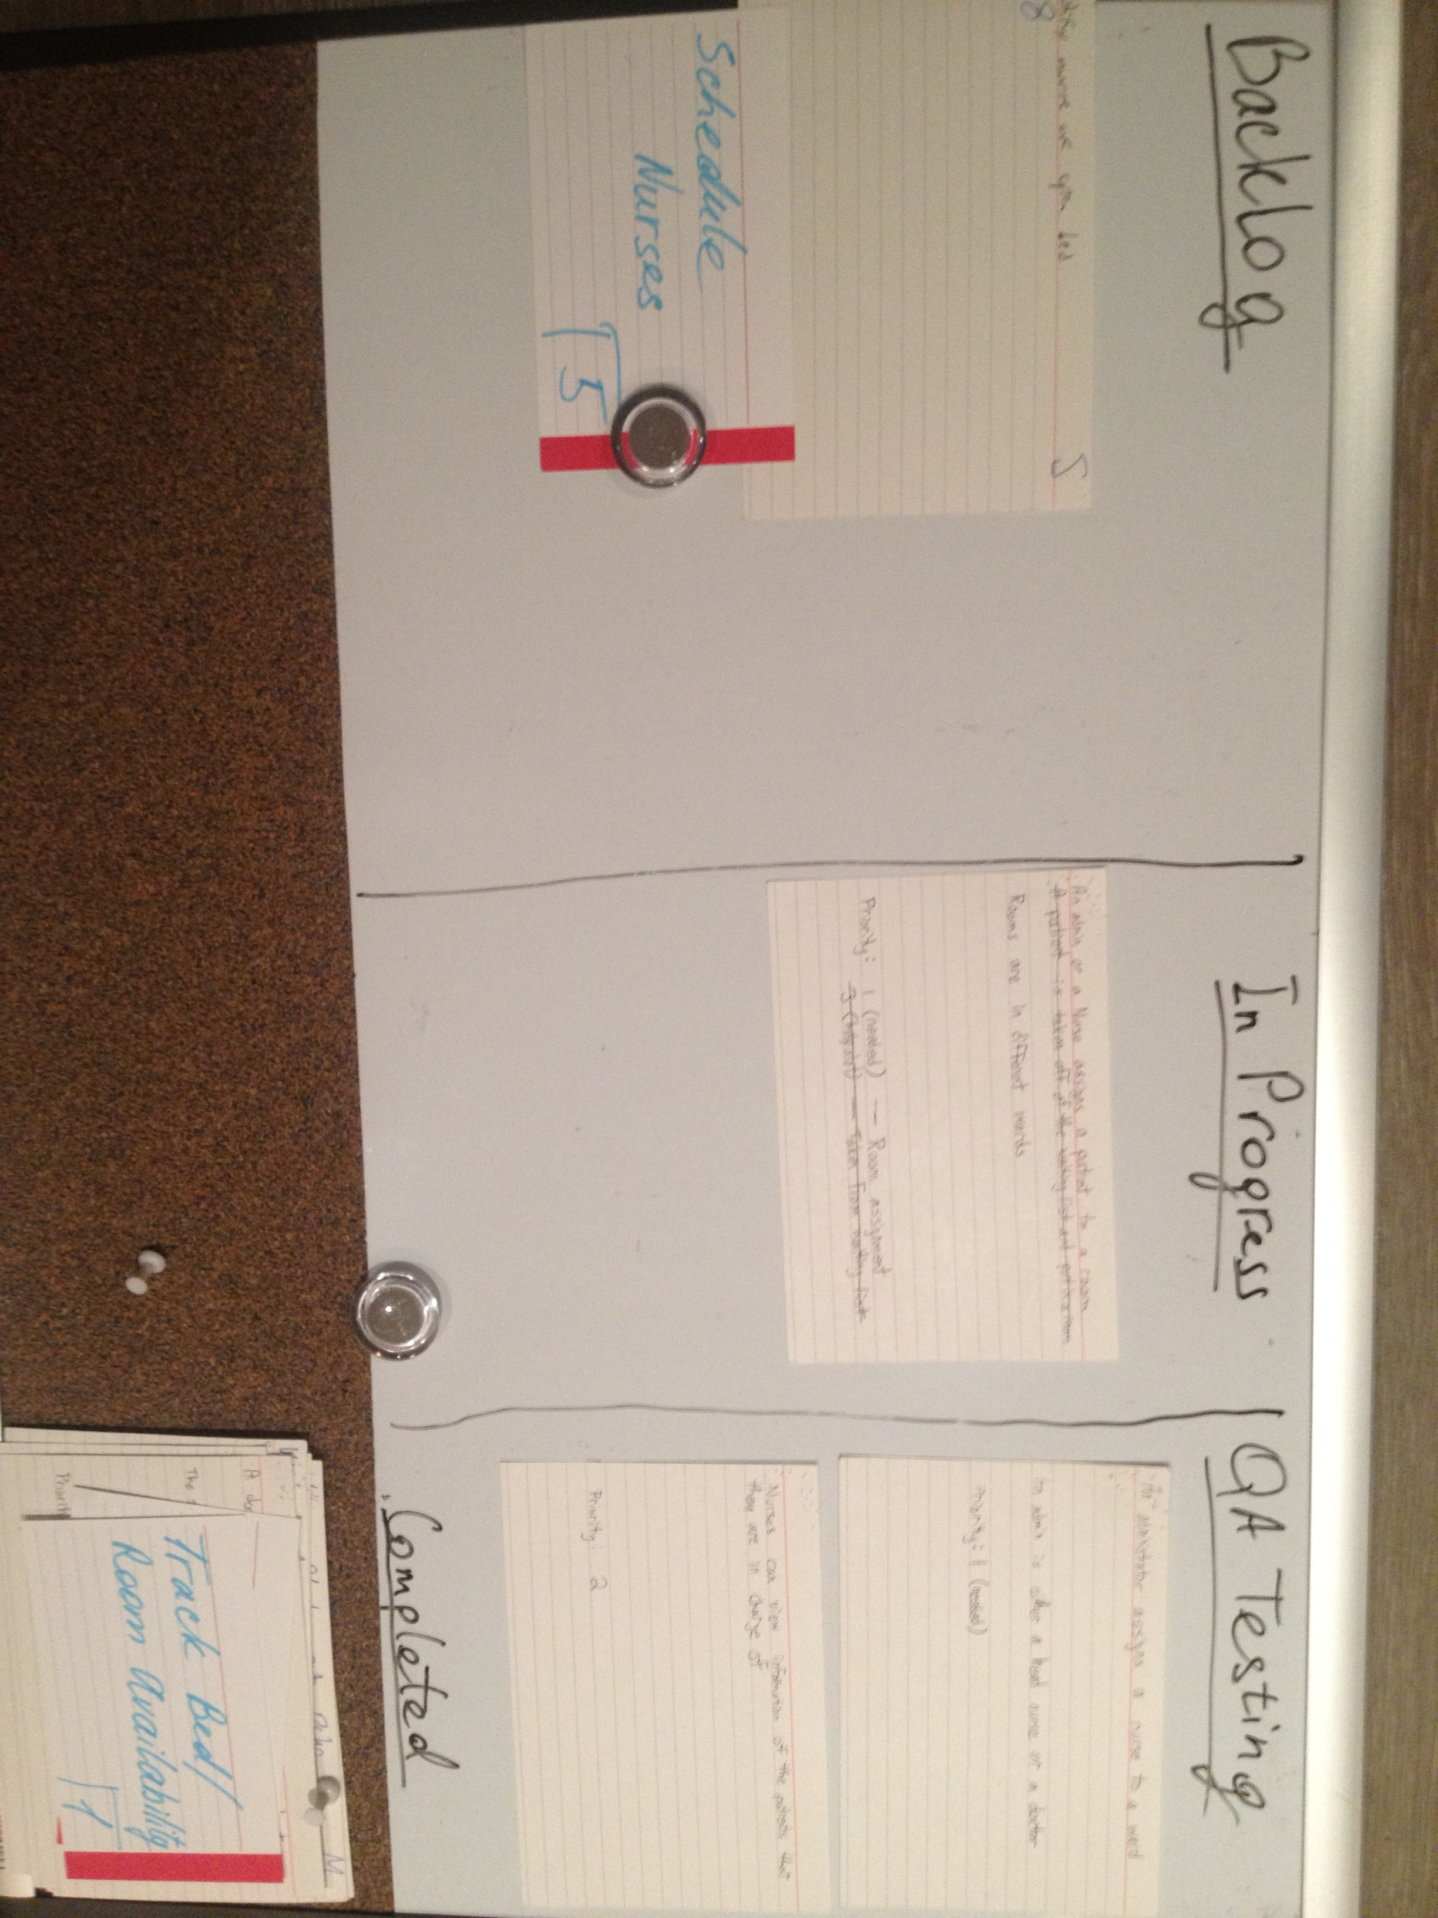

# System Evaluation

Design

Testing

Code Readability

Extensibility

Known Issues and Their severities

Use of Tool Support

# Work Distribution

**Thomas**

Tasks:

Stories:

**Mark**

Tasks:

Stories:

**Andrew**

Tasks:

Stories:

**Matthew**

Tasks:

Story:

**Ekaterina**

Tasks:

Stories:

**James**

Tasks:

Stories

# Appendix A – All Stories

Table . All stories with their priority and points

|  |  |  |  |
| --- | --- | --- | --- |
| **Number** | **Story** | **Priority** | **Points** |
| **1.1** | Assigning patients to rooms (This feature allows nurses or administrators to assign patients to specific rooms.) | **1** | **3** |
| **1.2** | Tracking Patient Information (This feature allows administrators to enter, edit, and view information about patients.) | **1** | **4** |
| **1.3** | Tracking Bed/Room availability (This feature keeps track of which beds and rooms are currently available, and which are currently occupied.) | **1** | **5** |
| **1.4** | Assigning Nurses to Wards (This feature allows administrators to assign nurses to wards.) | **1** | **3** |
| **1.5** | Encrypting of Patient Information (Patient information will be encrypted for security.) | **1** | **1** |
| **2.1** | Tracking Nurse Information (Doctors and head nurses can enter, edit nurses' information.) | **2** | **4** |
| **3.1** | Placing Patients in a Priority Queue (Patients will be placed in a priority queue to order them by the severity of their illness or injury.) | **3** | **5** |
| **4.1** | Searching for Patients (Nurses and Doctors can search for information about a specific patient.) | **4** | **3** |
| **5.1** | Scheduling Nurses (Administrators can create schedules to assign nurses to shifts.) | **5** | **5** |

# Appendix B – Backlog

|  |  |  |  |
| --- | --- | --- | --- |
| **Number** | **Story** | **Priority** | **Points** |
| **1.3** | Tracking Bed/Room availability (This feature keeps track of which beds and rooms are currently available, and which are currently occupied.) | **1** | **5** |
| **1.5** | Encrypting of Patient Information (Patient information will be encrypted for security.) | **1** | **1** |
| **4.1** | Searching for Patients (Nurses and Doctors can search for information about a specific patient.) | **4** | **3** |
| **5.1** | Scheduling Nurses (Administrators can create schedules to assign nurses to shifts.) | **5** | **5** |